


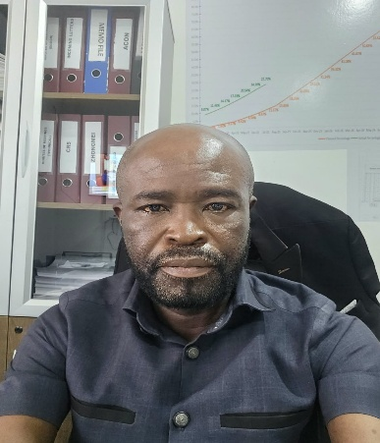
Ing. Ben Sackey
Project Manager
Bsc, Msc, EMBA, SPE-GhIE

Education
Msc, – Transportation Systems (Infrastructure & Engineering) Kwame Nkrumah University of Science & Technology (KNUST), 2023

EMBA – Project Management – University of Ghana Business School, 2011

Bsc (Hons) Civil Engineering
Kwame Nkrumah University of Science & Technology (KNUST), 2000.

Bachelor – Physics
University of Abomey-Calavi, 2007.

EMPLOYMENT
- 2024 – Now: Maripoma Enterprise Ltd, Project Manager
- Accra Tema Motorway project.

- 2020 – 2023: Municipal Development Collaborative (MDC), Supervising Consultant-Resident Engineer-Roads & Civil Works

- 2018 – 2020: Finnish Consulting Group
- (FCG –Sweden)
- (Supervising Consultant)
Senior Regional Field Engineer/International Expert-Liberia

Professional Overview
I am a highly experienced Civil Engineer and a Project Management Professional with over 25 years of experience; I have successfully managed various infrastructural projects both locally and internationally as expatriate professional. My expertise spans in infrastructure engineering design, Highway engineering, urban devolvement, Traffic survey & analysis, Contract management and supervision of structural systems, Roads & Transportation Engineering ensuring projects are executed with prudent management, precision, safety, and efficiency. A strong interest on quality assurance control with strict compliance to specifications and industry standards, Environmental and safety guards. Very skillful in managing teams, Stakeholders, coordinating with effective communications and strong negotiation skills, a team player in the execution of my project duties ensuring that, projects are completed on time.

Work Experience
- Contract for the Design of the Accra -Tema Motorway and Extensions Project (27.7km) and Construction of Section 1 – Tema Round about – Tetteh Quarshie Interchange (19.5km) Ghana (2024 – To date)
Project Manager
Responsible and leading the design team in the design of the 19.5km of the Motorway Road comprising of 4 lane concrete expressway and 6 lane asphalt concrete, including the design of 20 cross drainage structures, 3 bridges, 4 interchanges, 10 footbridges, side drains and other accessories.
Responsible for and the leading Engineer for the construction of the Project.
Responsible for and taking all decisions pertaining to the project. Chairing all meetings. Meeting all stakeholders. Maintaining all project communications with stakeholders. Leading site inspections with stakeholders, client and employer.
Responsible for design modifications standardization of quality control procedures and contract management. Responsible for project cost, time and quality management. Responsible for over 800 work force
Responsible for the management and maintenance of site camps Responsible for all project documentation and filing systems. A team player’
- The Construction of an Administration Block, 2 - Storey Dormitory Block, 3-Storey Dormitory Block, Vice Principal’s Residence, Library Block, Staff Flats and External Works at J.A Kuffour Senior High Technical School, Darbaa in the Atwima Nwabiagya North District. Ghana (2022 -2023)

+233-244-227983
Ing.benaackey@gmail.com
Tema, Accra, Ghana

ContacT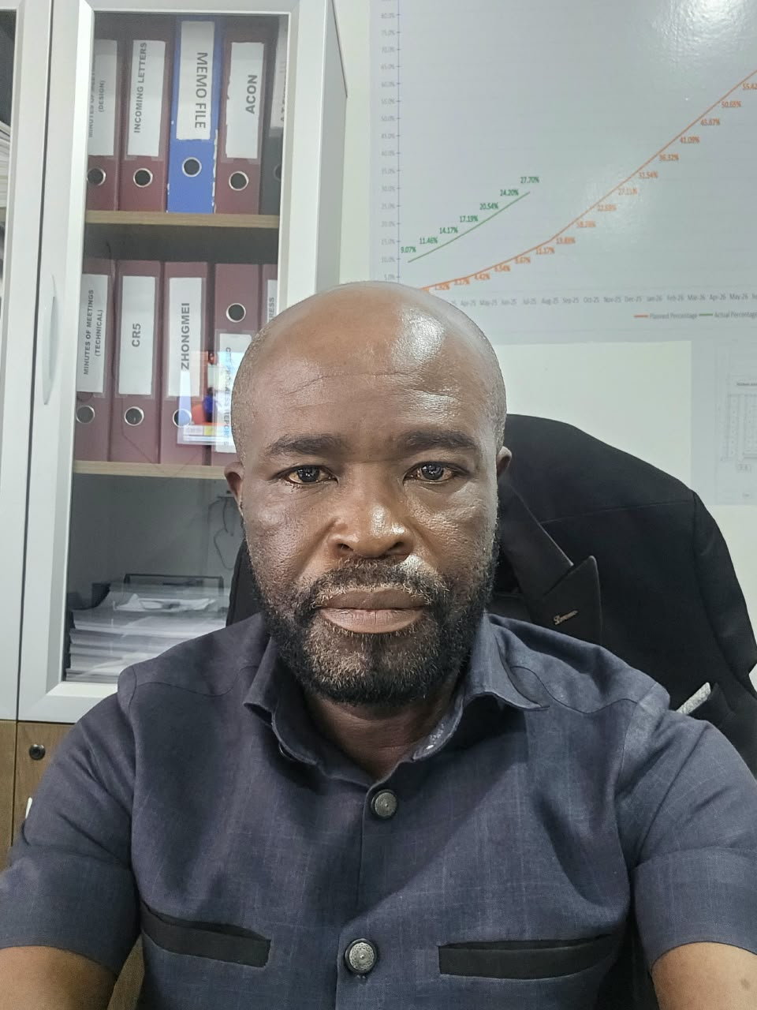t

EMPLOYMENT
- 2015 – 2017: Municipal Development Collaborative (MDC), Supervising Consultant-Resident Engineer-Roads & Civil Works
- 2013 – 2015: Transtech Consult Limited/ Louis Berger SAS France
- (Supervising Consultant)
- Highway Engineer/Contract Engineer

- 2007 – 2013: Municipal Development Collaborative (MDC), Supervising Consultant-Resident Engineer-Roads & Contract Engineer-Ghana

- 2003 – 2006:

- Taisei Corporation/Japanese
- (Contractor)
- Project Control Engineer/Assistant Project Manager-Ghana

- 2000 – 2003:
- Ghana Highway Authority (GHA) Ministry of Roads and Highways (MRH) Highway Engineer – Ghana

- 2000 – 2001:

- Ghana National Service Authority
- Graduate Teacher (National Service) -Ghana

Consulting Resident Engineer
Responsible for the design review and supervision of the internal roads network. Responsible for the construction of the all-roadside drains, roadside curbs and culverts. Design and supervision of Bituminous Surface sealing works. Design and construction of parking lots. Responsible for all external works supervision. Attending monthly stakeholder meetings. Leading by weekly site inspections with stakeholders. modification of designs, standardization of quality control procedures, Certification and Payment. Responsible for monitoring and supervising contractor’s site works. Designs Review and contract administration of the project execution. Coordinating with a team of engineers & Technicians. Preparation of progress reports

- Asphaltic Overlay of Selected Streets in Accra Phase II (120km),
Accra- Ghana (2020 -2022)

Consulting Resident Engineer
As the Resident Engineer to the Project am responsible for design review and contract administration of the project. Am Responsible and involved in the review of cost estimates, modification of designs, standardization of quality control. I developed and in charge of procedures, Certification and Payment. I was monitoring and supervising contractor’s site works. Coordinating with the team Leader in the discharge of his duties. Supervising engineers & Technicians. Involved in the Designs, Contract documentation, Evaluation and awards. Directly Involved in the Site Supervision for the asphalt Overlay. Reviewing the Contractor’s operations and construction planning. Preparing and approving IPCs inconjunction with the Quantity Surveyor. Chairing Meetings and organising monthly management meetings with stakeholders. Undertaking Site Monitoring and Supervision and issuing design changes and site instructions. Preparation and submission of monthly progress reports.

- Liberia Swedish Feeder Roads Project Phase III (LSFRP-3) 700km in Bong, Lofa, Grangedeh, River Gee, Grand Kru and Maryland Counties. Liberia (2017-2020)

Senior Regional Field Engineer (International Expert)
Assisting the Senior Road Implementation Engineer/Team Leader in the review of cost estimates, modification of designs, standardization of quality control procedures, Certification and Payment Responsible for monitoring and supervising contractor’s site works. Designs and contract administration of the project execution. Coordinating with a team of engineers and reporting to the Team leader. Designs, Contract documentation, Evaluation and awards. Monitoring all Contractual issues and Advises Team Leader/Senior Road Implementation Engineer on Claim Mitigation and Assessments.

Reviewing the Contractor’s operations and construction planning. Assisting Senior Road Implementation Engineer/Team leader in financial control, Evaluation and assessment of Contractual payments/claims, variation orders and documentation. Assisting Team leader in the administration of the Contract. Undertake Institutional Capacity Building through Training of National Field engineers and the Ministry of Public Works (MPW Counterpart Staffs) in Project Management, Site Supervision, Road Construction Techniques, Reporting, Road selection and Prioritization, Awards

- Accra and Tema Asphalt Roads Resurfacing Project 150km
Tema & Accra (2015-2017)

Consulting Resident Engineer
Project management and contract administration of the project, coordinating with a team of engineers. Monitoring all Contractual issues and Advises Team Leader on Claim Mitigation and Assessment Issues. Assisting the Team Leader in the review of cost estimates, modification of designs, standardization of quality control procedures. Certification and Payment Responsible for monitoring and supervising contractor’s site works. reviewing the contractor’s operations and construction planning. Assisting Team leader in financial control, Evaluation and assessment of Contractual payments/claims, variation orders, documentation and reporting. Assisting Team leader in the administration of the Contract.

- Design Review and Construction Supervision of Rehabilitation and Upgrading of Dodo Pepesu – Nkwanta Road (46.4 km) in Ghana (Eastern Corridor Roads) Ghana (2013-2015)
Consulting Highway Engineer/Contract Engineer
Am Responsible for all necessary Design Changes, project management. I am also responsible for Contract administration of the project, coordinating with a team of engineers. Monitoring all Contractual issues. Advising Team Leader/Resident Engineer on Claim Mitigation and Assessment Issues. Responsible for all necessary Design Changes and project management. Assisting the Team Leader/Resident Engineer in the review of cost estimates. Modification of designs, standardization of quality control procedures. Monitoring and supervising contractor’s site works. Reviewing the contractor’s operations and construction planning. Assisting Team leader/Resident Engineer in financial control, Evaluation and assessment of Contractual payments/claims, variation orders, documentation and reporting. Assisting Team leader/Resident Engineer in the administration of the Contract.

I am also responsible for Contract administration of the project, coordinating with a team of engineers.
- Monitoring all Contractual issues

- Advising Team Leader/Resident Engineer on Claim Mitigation and Assessment Issues.

